Security and Ethics on Artificial Intelligence

Name
Institutional Affiliations
Course
Professor
Date

Abstract
The new era's AI and robot technologies will have a huge effect on human development in the future. Such developments are beginning to raise some fundamental questions about how to use them, what risks they can pose, and how to handle them. This chapter delves into one of the most common and contentious AI and robotics topics: AI ethics. We begin with Asimov's Three Laws of Robotics to incorporate AI ethics. Following that, we look at some of the most important aspects and questions about AI ethics, such as robot's ethics, robot rights, moral agents, the opaqueness of AI systems, privacy & AI monitoring, automation and employment, prejudices in AI systems, responsibility for autonomous machines, and international AI ethic policy.

Security and Ethics on Artificial Intelligence
Introduction
Artificial intelligence (AI) is a broad field of computer science that focuses on creating intelligent machines that can perform tasks that would normally require human intelligence. While AI is a multidisciplinary science with many methods, advances in machine learning and deep learning are causing a paradigm shift in nearly every tech industry field. Alan Turing changed history. Less than a decade after the Nazis cracking the Enigma machine encryption and helping the Allies win World War II, mathematician Alan Turing changed history once more with a simple question: "Can machines think?" (Smith, 2014). According to Norvig and Russell, four different approaches to AI have characterized the field in the past. The four approaches include the ability for machines to think humanly, think rationally, acting humanly, and acting rationally.
Artificial Intelligence (AI) and Machine Learning (ML) are commonly regarded as far-fetched innovations over which we have little or no influence. They're often related to dystopian scenarios in which robots take control of the world (Siau & Wang, 2020). These modern technical methods are now a part of our everyday lives. They're part of a rising trend in business growth that's opened up new opportunities. AI and machine learning are now in use across a wide variety of sectors, including banking, advertising, online shopping, and. as such, there are key concerns that arise with the high penetration of AI and machine learning given the high use and reliance in the contemporary world (Kriebitz & Lütge, 2020). The major concerns include the ethical concern and the technologies' security to ensure they are not infiltrated by hackers, thereby risking users' and organizations' data to misuse.
On the one hand, AI and machine learning are a big step forward in the fight against hackers and cybercrime because they serve so many practical purposes. Password security and user authentication, detecting phishing and spam attempts, spotting fake news, and so on are all areas where AI can help (Gill, 2019). On the other hand, malicious use of AI poses an immediate threat to digital, physical, and political security by enabling large-scale, finely tailored, and highly efficient attacks, such as on our vital infrastructures. Researchers are now collaborating with law enforcement and industry to enhance the identification of illegal activity and the use of data and virtual reality in criminal investigations (Ryan & Stahl, 2020). Intelligence is developing tools to combat cybercriminals who may use AI-powered technologies, for example, picking potential victims for financial crime and "social engineering" attacks (Yampolskiy, 2018). however, there is no way to prevent AI from being used for illegal purposes.
Literature review
Since ethical standards vary from one individual, organization, and society to others, regulation through laws has been introduced in various jurisdictions across the world. The rules come in handy in determining and averting the AI-powered cyber-attacks, the ethical issues associated, and imposes hefty fines or incarcerations as punishments (Subramanian, 2017). Regulations solve the paradox of counter-attacks as a defense mechanism. However, by regulating the terms of practice in AI and robot technologies, organizations and governments should be keen not to kill the advancements and the positive aspects of these modern technologies. Still, they must only move to arrest the adverse outflow that comes with the technology, such as the criminal activities therein (Currie et al., 2020).
Considering the impacts of the AI technology and security threats associated, AI ethics and safety must be regarded as a priority in the design and use of AI systems. The ethical measures ensure that optimal public benefit is achieved (Lo Piano, 2020). To achieve the standards required, it will take a collaborative effort on the team's part from data scientists, product managers, data developers, domain experts, and implementation managers to align artificial intelligence technology development with ethical standards, values, and principles that protect and foster the well-being of the communities in which these companies operate Technologies have an impact (Thomsen, 2019).
Methods
The articles considered for the analysis of this topic were published from different sources such as the public office and the CRC Press. The article's sample size was 15, and their titles and frequencies were recorded in table 2 below. About 13% of the articles obtained were from Ethics and Information Technology, while the rest of the articles came from different unique sources.
Table 2
Journals/ Conference titles | frequency | percentage
European Journal of Nuclear Medicine and Molecular Imaging | 1 | 7%
Ethics and Information Technology | 2 | 13%
Publications Office | 1 | 7%
Ethics & International Affairs | 1 | 7%
THE GEORGETOWN JOURNAL OF LEGAL ETHICS | 1 | 7%
Business and Human Rights Journal | 1 | 7%
Zenodo | 1 | 7%
Humanities and Social Sciences Communications | 1 | 7%
Journal of Information, Communication, and Ethics in Society | 1 | 7%
Journal of Database Management | 1 | 7%
Paladyn, Journal of Behavioral Robotics | 1 | 7%
Cambridge University Press | 1 | 7%
Random House | 1 | 7%
CRC Press | 1 | 7%
Total | 15 | 100%
Results
This part includes analyzing the articles' yearly distribution addressing this topic from 2014 to 2020, as indicated in table 3 below.
Table 3: Yearly distribution of the articles
year | amount | percentage
2014 | 1 | 7%
2016 | 1 | 7%
2017 | 1 | 7%
2018 | 2 | 13%
2019 | 4 | 27%
2020 | 6 | 40%
Total | 15 | 100%
From the above table, it was observed that the year 2020 had the most articles addressing security and ethics on artificial intelligence. These results are presented in the pie chart below, indicating the percentage of distribution of the articles.
Graph 1: Pie chart indicating the yearly distribution of the articles
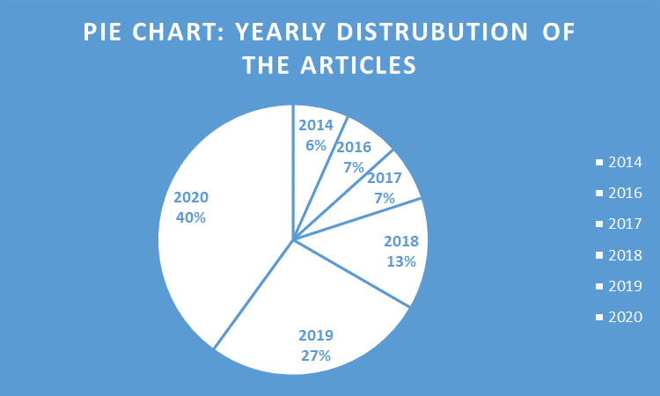
Based on the above pie chart, about 40% of the article addressing this paper's topic was published in 2020 followed by 2019 with 27%. The year with the least publication based on the collected articles was 2014, with about 6% of the distribution. Lastly, the years 2018, 2018, and 2020 made up to more than 50% of the article distribution, translating to increased security and ethics issues on artificial intelligence.
Limitation and Conclusion
The review on the topic for this study in the various articles is well covered. However, the method for obtaining the articles was restricted to the most recently published articles. Therefore, the sample size was limited to a small size. The use of peer-reviewed articles could help address some issues in a given environment. The more there is independently researched a certain field and using the primary methods of collecting data, the more accurate the results are. Also, from the analysis, we can conclude that a certain topic can be covered by several auditors depending on the rate of its influence. For instance, more articles addressing issues in the field of security and ethics on artificial intelligence were in 2020 than in other years indicate that there was more impact on the same area that drew many authors' attention.

References
Currie, G., Hawk, K. E., & Rohren, E. M. (2020). Ethical principles for the application of artificial intelligence (AI) in nuclear medicine. European Journal of Nuclear Medicine and Molecular Imaging, 47(4), 748–752. https://doi.org/10.1007/s00259-020-04678-1
Gill, A. S. (2019). Artificial Intelligence and International Security: The Long View. Ethics & International Affairs, 33(2), 169–179. https://doi.org/10.1017/S0892679419000145
Kriebitz, A., & Lütge, C. (2020). Artificial Intelligence and Human Rights: A Business Ethical Assessment. Business and Human Rights Journal, 5(1), 84–104. https://doi.org/10.1017/bhj.2019.28
Lo Piano, S. (2020). Ethical principles in machine learning and artificial intelligence: Cases from the field and possible ways forward. Humanities and Social Sciences Communications, 7(1), 1–7. https://doi.org/10.1057/s41599-020-0501-9
Ryan, M., & Stahl, B. C. (2020). Artificial intelligence ethics guidelines for developers and users: Clarifying their content and normative implications. Journal of Information, Communication and Ethics in Society, 19(1), 61–86. https://doi.org/10.1108/JICES-12-2019-0138
Siau, K., & Wang, W. (2020). Artificial Intelligence (AI) Ethics: Ethics of AI and Ethical AI. Journal of Database Management, 31, 74–87. https://doi.org/10.4018/JDM.2020040105
Subramanian, R. (2017). Emergent AI, Social Robots and the Law: Security, Privacy and Policy Issues. 26(3), 27.
Thomsen, K. (2019). Ethics for Artificial Intelligence, Ethics for All. Paladyn, Journal of Behavioral Robotics, 10(1), 359–363. https://doi.org/10.1515/pjbr-2019-0029
Yampolskiy, R. V. (2018). Artificial Intelligence Safety and Security. CRC Press.

